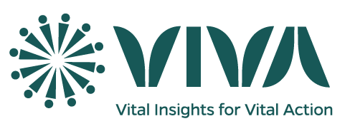**Written vs. Oral Consent Forms**

**Written vs. Oral Consent in the Context of COMSA-Mozambique:**

COMSA-Mozambique, a community-based mortality surveillance system, uses written and oral consent forms to ensure informed participation in data collection on deaths, births, and causes of death. Initially, the system relied solely on written consent but later introduced oral consent during the COVID-19 pandemic to minimize physical contact. Both methods, approved by institutional review boards (IRBs), cover identical content tailored to specific data collection activities, ensuring participants understand the study’s purpose and their rights.

COMSA utilizes seven written consent forms: 1) Adult pregnancy/birth/death, 2) Adult VASA, 3) Child assent for pregnancy/birth/death, 4) Child assent for VASA, 5) Household data, 6) Parental permission for pregnancy/birth/death, 7) Parental permission for VASA.

**Reasoning for Use of Written Consent Forms:**

Written consent, requiring a signature, ensures legal documentation, enhances accountability, and supports traceability, particularly for sensitive topics like child deaths or verbal autopsies, which investigate causes of death through interviews.

During the COVID pandemic, oral consent forms were used to maintain social distancing and mitigate the spread of infection between data collectors and participants. The content of the oral consent forms were identical to that of the aforementioned written consent forms, with the only difference being that participants were asked to verbally consent to participate in the study, rather than providing a signature on a form.

**Reasoning for Use of Oral Consent Forms:**

Oral consent, introduced to maintain social distancing during COVID-19, is also used in cases of low literacy or cultural preference, with participants verbally agreeing after hearing the same information as in written forms. Consent is documented via audio recordings or witness verification to ensure ethical compliance. This approach minimizes barriers to participation while upholding informed consent principles, with clear communication tailored to participants’ comprehension levels, especially for vulnerable groups like children or parents.

**Approval of Consent Forms:**

All consent forms, whether written, oral, or both, must be approved by the relevant IRB(s) to ensure ethical alignment with local and international standards. Plan IRB submissions at least three months before data collection, accounting for translation, local requirements, and potential delays. Engage local IRBs early to navigate varying regulations, ensuring timely approval and culturally appropriate consent processes.